**Mapping ERD to Relational Schemas**

1. Performance(Performance_ID, Date, Start_Time, End_Time, Stage_ID[FK], Artist_ID[FK])
2. Artist (Artist_ID, Name, Genre, Artist_Type, Contact_Info, Stage_Preferences)
3. Stage(Stage_ID, Stage_Name, Capacity, Area_ID[FK])
4. Area(Area_ID, Area_Name)
5. Employees(Employee_ID, Employee_Type, Name, Role, Contact_info, Shift, Area_ID[FK])
6. Buyer(Buyer_ID, Name, Buyer_contact, Ticket ID[FK])
7. Order(Order_ID, Date_Purchased, Ticket_Count, Buyer_ID[FK], Ticket_ID[FK])
8. Ticket(Ticket_ID, Price, Ticket_Type, Stage_Access, Buyer_ID[FK])

**Coachella ERD**

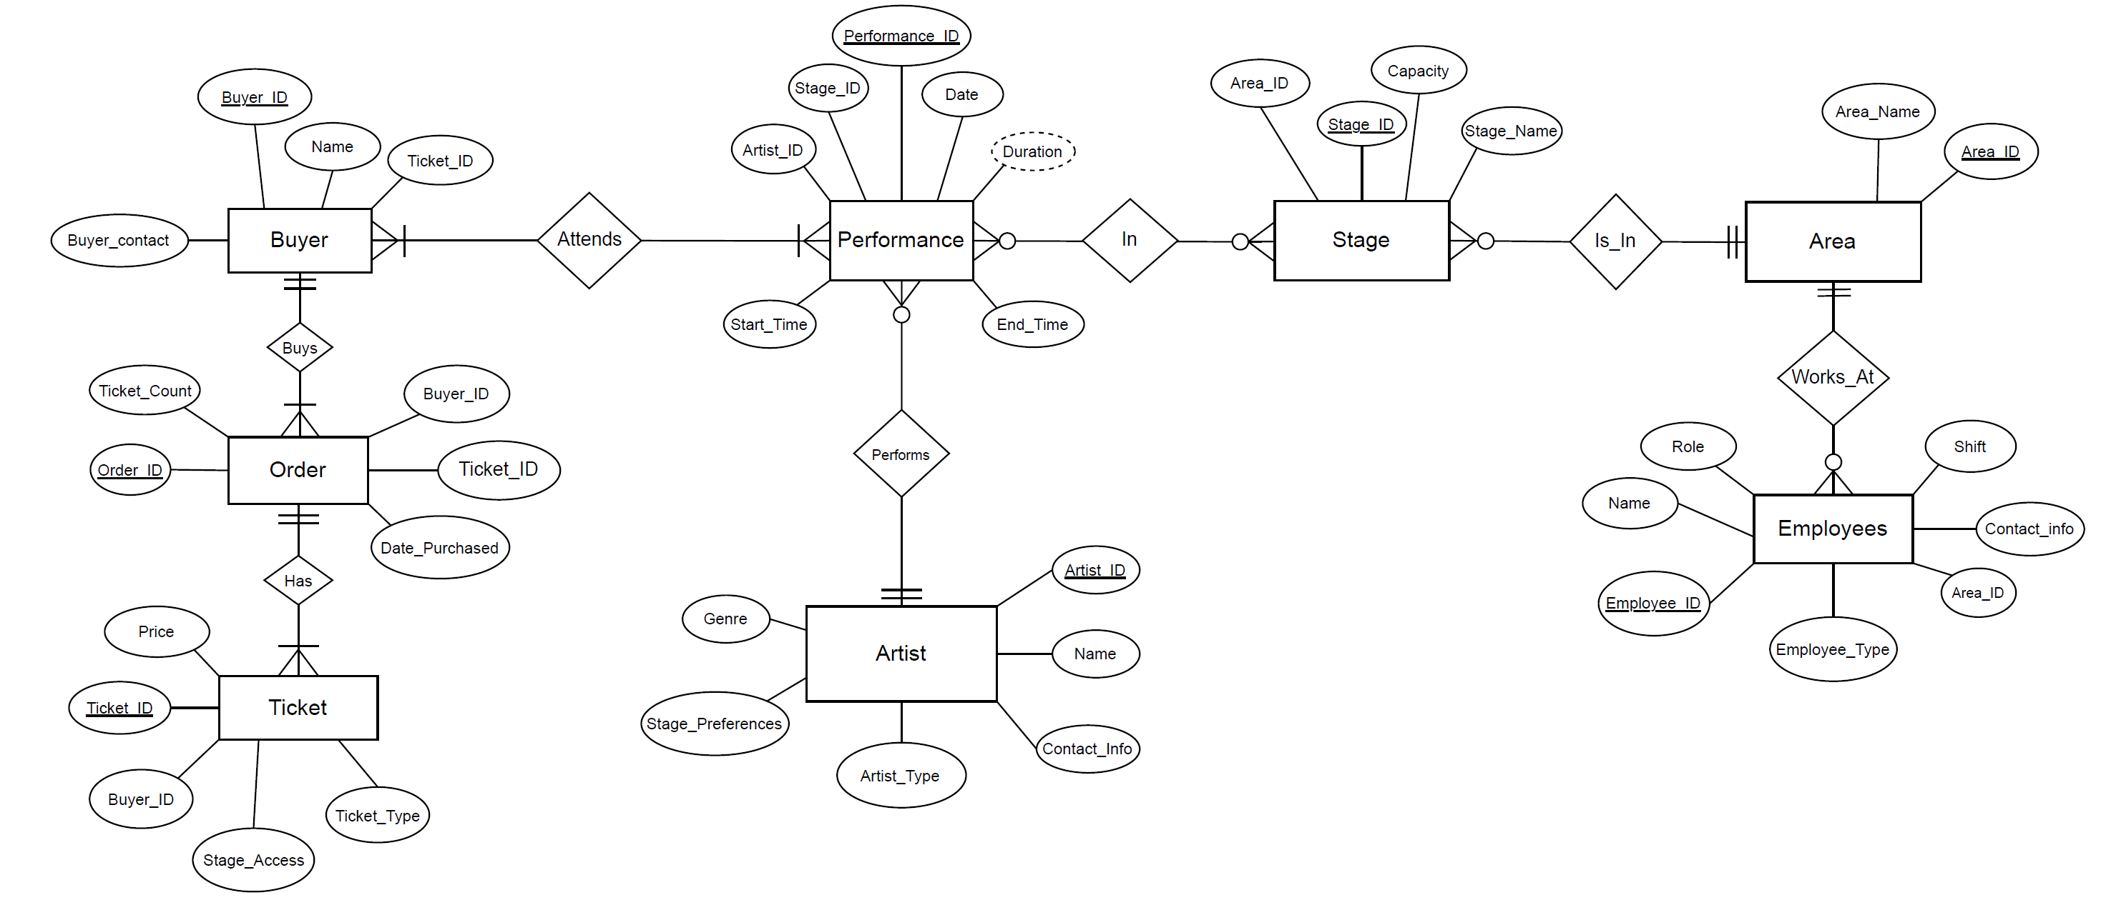

**Assumptions:**

* This ERD represents the festival as a whole, not a specific performance of the festival.
* Each ticket can be sold only once, there are no duplicate tickets.
* One buyer can place an order with multiple tickets, but an order is under one person's name.
* Employees are assigned a working area. Each area has multiple stages, but stages can only be in one area.
* Buyer Contact Details: Contact information for the buyer is stored in the Buyer entity.
* Duration (in hrs.) for Performance is derived from the Start_Time and End_Time.

**Relationships:**

1. : Performance – Stage – Artist: PSA

* This relationship captures the interaction where a specific artist performs on a stage during a scheduled performance.
* PSA represents this ternary relationship.
* Performance to PSA: Mandatory one-to-many relationship.
* Stage to PSA: Mandatory one-to-one relationship.
* Artist to PSA: Mandatory one-to-many relationship.
* Attributes of PSA:
  + Performance Duration: Derived attribute based on start and end times.

2. Buyer – Order:

* A buyer can place only one order and each order belongs to only one buyer.
* This is a one-to-one relationship.

3. Order – Ticket:

* An order can contain multiple tickets, and a ticket can appear in only one order.
* This is a one-to-many relationship.

4. Stage – Area:

* A stage belongs to mandatory one area, but an area can have mandatory one or multiple stages.
* This is a many-to-one relationship.

**Strong-to-Weak Entity Relationships:**

* Stage – Area: Each stage depends on the existence of an area. If an area is removed, all associated stages will also be removed.